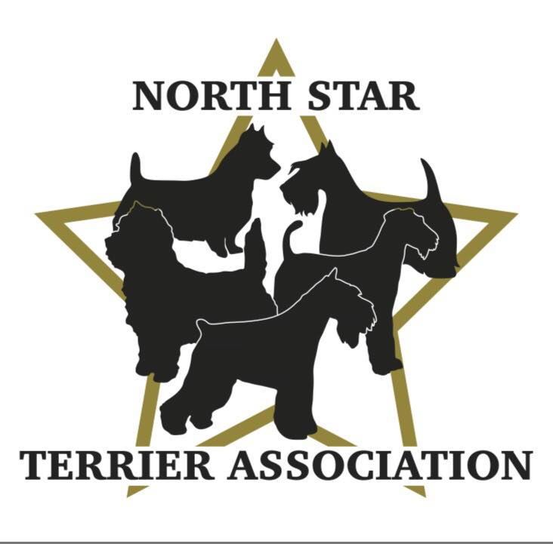

GENERAL MEETING NOTES
July 27th, 2023, 7:00pm, Via Zoom

MINUTES PENDING APPROVAL:
The meeting was called to order by Vicki Barker at 7:06pm.

ROLL CALL:

Member Attendees:
Vicki Barker, Patty Patzman, Donna Bonnicksen, Carol Dorris, Brenda Holmen, Dick Rueter, Brenda Ugoretz, Peggy Gerold, Erin Warshaw, Sylvia Mills

OFFICERS REPORTS:

Reading of 6/01/23 Minutes-members were asked to review the minutes on the NSTA website in lieu of reading them. No comments. Patty P. Motioned to Accept, Donna 2nd. All Ayes. APPROVED.

Treasurer Report-Read. APPROVED.

OLD BUSINESS:

TERRIER SPECIALTY-August 24th starting at 9:00am at Lake Elmo Fairgrounds (part of SCVKC Show):

Trophies, Prizes and Gifts:
- Perpetual Trophies for BIS, Best Puppy in Show and Best Veteran in Show-Carol confirmed are ready to pick up.
- Totes with Logo for Breed Winners-Carol confirmed will be ready to pick up next week. 50pcs were ordered-anticipate using 25 for breed, 3 for judge’s gifts and the rest will be sold to members prior to and at show (Carol and Patty R. will handle this).
- Plaques for BIS, Best Puppy in Show and Best Veteran in Show-Carol confirmed are ready to pick up.
- Hand Towels for breed winners, 1st, and 2nd placement (purple, blue, and red embroidered)-Vicki confirmed are in hand.
- Hand Towels for NOHS (white with colored embroidery reflecting placement)-Vicki confirmed are in hand.
- Lamb Chop toys for Puppy winners-Vicki confirmed are in hand.
- Tug toys for Obedience/Rally winners-Peg confirmed are in hand.
- Buckets with Logo for Junior Handler winners-Vicki confirmed she has buckets; Patty P. will give her stickers to put on bucket.
- Judge’s Gifts (3) with MN theme (chocolate, wild rice, etc.)-Vicki confirmed items are purchased, will put in logo tote, and include note using logo notecard.
- Ribbons and rosettes are ordered for all events.
Set Up/Clean Up:
- Brenda U. will set up what she can Wednesday night-tables provided by SCVKC inside (ribbons, etc.)/outside (armbands, etc.) and club banner.
- People should be at set up area Thursday morning by 7:30 to help with additional set up needs.
- Brenda H. will lend club one 6ft table and tablecloth for displaying and organizing the trophies, prizes, and gifts.
- Diane S. is making flower arrangements that we can use to decorate the table.
- Patty P. will bring plate stands to display plaques.
- All will help with clean up.
Miscellaneous: will handle getting lunches for the judges.
- Vicki will be the ring steward. Brenda U. and Dick volunteered to help.
- Donna needs ring stewards for obedience. Erin volunteered to help. Carol will send email looking for more volunteers.
- Donna will handle getting lunches for the judges from food trucks.
Hospitality:
Patty P. started discussion:
- Set up will be shared with Airedale and Fox Terrier Clubs.
- Patty P. will work with team to set up 2-10ft tents together-10ft away from building. She will run power cords to a nearby camper. Inside, the tent will be “decorated” with floor mats and bistro tables with chairs (latter provided by Airedale Club). Will have made and will hang a club logo banner on outside of tent.
- Patty P. will lend club 2-6ft tables to use in tent along with plastic covers (purchase latter).
- Vicki and Brenda U. will send Patty P. a list of what supplies they have for the tent (cups/napkins/trash cans etc.). Will coordinate dropping off to her ahead of time if necessary.
- Patty P. will purchase packaged foods (pastries, granola bars, chips, cookies, coffee, creamer, etc.) and whatever supplies are still needed for 100 people. She will provide an organizer with drawers to put out food.
- Patty P. will provide a 5-gallon water cooler, water jugs, party perk and coffee perk.
- Patty R. will make signs letting people know about the Hospitality area to display near show ring-one on an easel (Carol will bring easel) and one framed for table. Patty P. will have one additional sign made to put out on side of road.
- Donna and Peggy will bring membership applications. Patty R. will make sign and bring holder to display in tent.
- All will help with clean up.

STATE FAIR:
- NSTA will participate on Saturday, 9/3. Volunteers as follows:
  - Brenda U./Larry Lemke-8:00am -12:00pm (will set up). Might swap with Patty P.
  - Patty P. -12:00pm-4:00pm.
  - Dick-4:00pm-8:00pm (will take down).
NEW BUSINESS:

Terrier Specialty 2024:
Brenda U. started discussion:
- We will need 3 judges for the August 2024 Specialty-one each for Class Show, Sweep and NOHS.
- Brenda U. detailed criteria for them to be able to judge our specialty August 2024.
- Brenda will begin checking on several judges to make sure there are no conflicts and will begin reaching out to them about the show.

Ring Stewarding Seminar:
- Brenda U. suggested doing a seminar on ring stewarding as an educational event for the club.
- The AKC provides videos on this which could be tied in to an in-person event which Brenda H. said she would help with.
- Brenda U. will prepare a proposal-potential timing February.

Grooming Seminar:
- Many members are being asked or asking when the next grooming seminar will be. This will be discussed further at the next BOD meeting.

NEW MEMBERSHIP APPLICATIONS:

2nd Reading- Margo Griffith (Kerry Blue Terriers-Rochester MN). Dick and Donna sponsors. All ayes! WELCOME TO THE CLUB MARGO!!

Meeting adjourned at 8:15pm.

