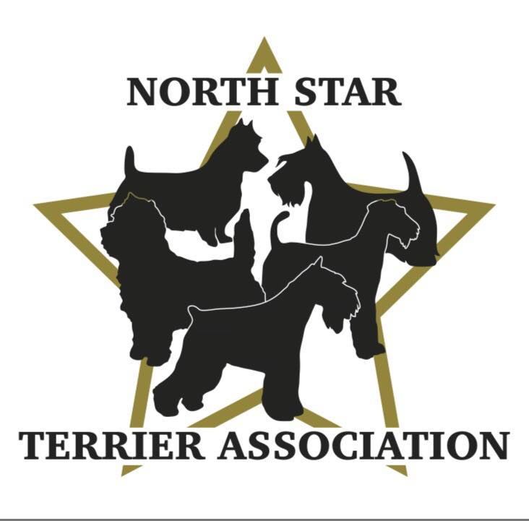

GENERAL MEETING NOTES
March 28, 2024, 7:00pm, Via Zoom

MINUTES PENDING APPROVAL:
The meeting was called to order by Vicki Barker at 7:08pm.

ROLL CALL:

Member Attendees:
Vicki Barker, Donna Bonnicksen, Carol Dorris, Patty Patzman, Brenda Holmen, Patty Reiman, Dick Rueter, Kari Ditty, Karla Edwards, Peggy Gerold, Larry Lemke, Lynette Spitzer, Brenda Ugoretz, Erin Warshaw

OFFICERS REPORTS:

Reading of 1/25/24 Minutes-members were asked to review the minutes on the NSTA website in lieu of reading them. No comments. Patty P. motioned to Accept, Brenda H. 2nd. All Ayes. APPROVED.
Note: next general meeting will include a copy of the minutes when the invitation/agenda is sent out to members.

Treasurer Report-Donna read the YTD (through February) financial report. Income was $$30.005, Expenses were $159.17, Profit was $145.83. The balance in the club account as of 2/29/24 is $9,017.00. This does not include the $776.00 collected for the Specialty Sponsorships in March. Kari motioned to accept, Carol 2nd. APPROVED.

MEMBERSHIP APPLICATIONS:

2nd Reading:
- Ross & Valerie Reinhiller-North Dakota, Border Terriers-Sponsored by Carol & Donna. Donna motioned to accept new members, Carol 2nd. All Ayes.
CONGRATULATIONS and WELCOME TO THE CLUB ROSS and VALERIE!

1st Reading:
- Linda Terry-St. Paul, MN, Cairn Terriers-Sponsored by Kari, and Carol. 2nd reading will take place during the next General Membership Meeting on 5/23.
OLD BUSINESS:

Terrier Specialty 2024:

Judges Contracts Completed:
- David Alexander will judge all Terrier Classes, Group & BIS.
- Camille McArdle will judge NOHS.
- Katy Holmen will judge Puppy & Veteran Sweeps, Junior Showmanship.
- Debra Schneider will judge Obedience & Rally.

Entry Fees Finalized:
- Conformation-$32 first entry, $26 additional entries same dog.
- Puppy & Bred By-$22.
- Sweeps & Veteran Sweeps-$15.
- Juniors-$10.
- Obedience/Rally-$30 first entry, $20 additional entries same dog.

Trophy/Awards Finalized:
- Best of Breed Winners-Club Logo Slip Lead in decorative sack
- Best Puppy in Breed-Fur Squeak Toy
- Best Veteran in Breed-Fleece Crate Pad in decorative sack
- Variety Group Winners, Junior Best & Reserve Winners-Custom Rosette offered by NSTA Club and Cash Prizes offered by members of NSTA (collected donations of $776 to cover this).
- Obedience/Rally- Custom Rosette offered by NSTA Club and Cash Prizes offered by members of NSTA (collected donations of $776 to cover this). All first-place qualifiers will also win a Fur Squeak Toy in decorative sack.
- To date we have collected $365 in donations (above and beyond sponsorship) to put towards the awards.

Show Application and Premium List:
- Brenda will follow up on applications which are listed as pending to see what else is needed to receive confirmation (needs to be done by 4/03).
- Brenda submitted premium list on 3/27. She will send copy of premium list to BOD to review since deadline was extended to 4/01 for submission. Since SCVKC/Onofrio want to post as early as possible, they are asking clubs to be as accurate and complete as possible to avoid many changes on second review which could cause delays.

Advertising:
- Vicki will work with Dick S. to get bookmark information that can be modified for our event and handed out by our members.
- Vicki will work with person who did flyer for the Minneapolis KC event to create flyer we can post on FB, website and share with regional clubs.
- Carol will work with Theresa to learn more about FB Boosts (cost and how to do it).
- Teasers-as we get closer to event date, will start positing teasers on FB including pictures of rosettes, prizes, etc.

Ring Stewards:
- Vicki volunteered to be chief ring steward again for this year’s show (thank you).
- Will need to send an email out to look for volunteers to help outside the ring and inside when needed.

Hospitality:
- Patty P. working with Airedale and Fox Terrier Clubs on concept for the Hospitality Tent which they would like to have set up for whole weekend.
- Will need to create a schedule this year to make sure there is always someone in the tent-can include Juniors.
- Will need to review what we can use from last year (supplies like plates, napkins, cups, etc.) and then come up with a budget (LY was $150).
- Signage and where it is placed will be key this year since the tent does get partially hidden by cars unless we can change location.
- Will check with SCVKC to see if we can relocate closer to where we are showing so people can see.

Schedule/Time Sheet:
- The group agreed the best way to manage the show is to create a schedule/time sheet for people to sign up for all tasks involved with the show including from set up to take down and everything in between.
- Peg had done a schedule for the Minneapolis show which she will send to Carol to modify for NSTA show that can then be sent to members to sign up on.

Website Donations Page:
- A new page has been set up on the NSTA website for members to make donations to help with costs for the upcoming specialty (starting at $10 up to $50 in intervals of $10). Can pay by PayPal or Check.
- Carol will send out email to members to let them know

Grooming Seminar:
- Lynette is working on finding a venue and getting a date (trying for May) to hold the seminar.
- Once confirmed, details will be finalized and then members will be notified via email.
- Will open up to participants not in the club (like LY) promoting on FB, through local clubs, salons, etc.

Performance Survey Update:
- Erin reviewed the results of the Performance Survey sent to members which had an amazing 58% response rate.
- Of the members that participated in performance, the top 5 events were as follows:
  - 54% Obedience/Rally
  - 39% Barn hunt
  - 36% Fast Cat
  - 29% Agility
  - 25% tied for Nose/Scent Work and Earth Dog
  - Additional-7% each for Tracking, Dock Diving & Protection Training and 4% for Disc Dog
- 25% of members survey never participated in Performance
- All members were interested in learning about and possibly participating in one or more of these events.
- A number of members who have experience in one or more of the events offered their time to help as the club explores how to develop this category (Thank you)!
- Ideas on how to get started including zoom/in person sessions, short demos, info sessions.
- Agreed to start by doing a presentation at our next general meeting on 5/23 on Fast Cat and Dock Diving.
  - Will include information about the event, pictures, and a list of places in the area that will be running these events so members can take part (possibly if enough interest, create a group to go together).
  - Will email this info with the meeting agenda to help with discussion and spark the interest of members to join.

NEW BUSINESS:

Small Dog Club Helpers:

- Patty P. discussed Small Dog Club Helpers-a FB group that helps clubs earn money by auctioning items on line and sharing the earnings.
- She confirmed that they do require SOME members of the club to participate but many outsiders also bid.
- Proceeds are split between the administrator (Kathy Knoles & Club)-need to confirm breakout.
- Patty P. will confirm the specifics to send to the BOD.

Dick motioned to adjourn meeting, Patty P. 2nd. Meeting adjourned at 8:45pm.

