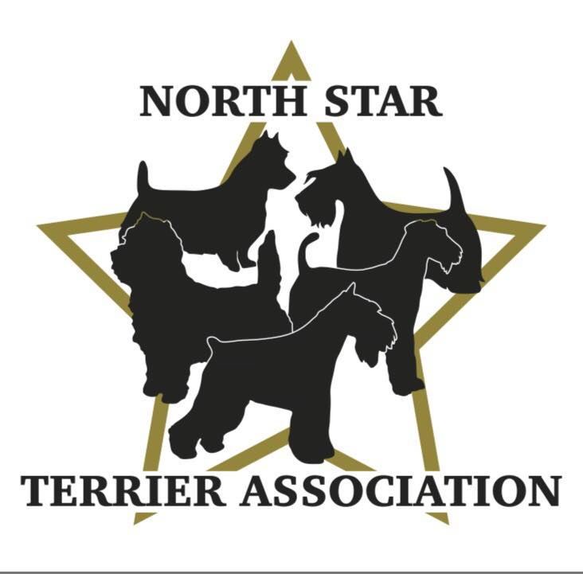

GENERAL MEETING NOTES
MARCH 23rd, 2023, 7:00pm, In Person (Casper’s) & Via Zoom

MINUTES PENDING APPROVAL:
The meeting was called to order by Vicki Barker at 7:05pm.

ROLL CALL:

Member Attendees:
Vicki Barker, Donna Bonnicksen, Carol Dorris, Tiffany Heubner, Brenda Holmen, Larry Lemke, Sarah Mathies
Sue Osborne, Patty Patzman, Diane Schlicht, Dick Schlict, Jennifer Stevenson, Brenda Ugoretz, Erin Warshaw

Welcome to our new members-Erin, Jennifer, and Tiffany.

OFFICERS REPORTS:

Reading of 1/26/23 Minutes-members reviewed ahead of meeting on website. No changes suggested. Approved.

President Report-nothing to report for this meeting.

Secretary Report-nothing to report for this meeting.

Treasurer Report-reviewed status of accounts and expenditures.

OLD BUSINESS:

Grooming/Handling/Sparring Seminar-June 10th at BOTC:
Patty R. and Carol working on Flyer and Application. Will send prior to 4/27 BOD meeting so can be finalized at meeting.
Pricing confirmed-$75 grooming (9-12), $50 handling (1-3), $10 sparring (3-4). Lunch (12-1 catered from Davanni’s-Carol to arrange) included if participate in both grooming and handling. Set up 8:15-Cleanup 4-5. Preference for participants to bring own dogs/table/supplies but club members can provide if necessary. Limit of 30 people. Apply and Pay On Line via NSTA website (Donna and Theresa will manage this). Donna will take care of parking. Promote on website, FB (our site, grooming groups)-need all members help to promote to other clubs, salons, etc.

Terrier Specialty-August 24th at Lake Elmo Fairgrounds (part of SCVKC Show):
Vicki confirmed applications and premium list has been submitted. Approval by AKC pending.
Last year there were 126 entries. Need to heavily promote weekly on FB and website once all is confirmed to get word out early and build the entries.

Committee Reports:
- Hospitality-Patty P. requested same spot as last year to set up tent. This year will offer to all attending the Terrier Specialty. Will serve coffee (Vicki has large coffee pot), water (Patty P. has water cooler) and wrapped snacks. Allocated $150 to buy what is needed.
- Set Up/Clean Up-Brenda U. and Larry L. graciously agreed to take this on with the help of members.
- Other Committees-will follow up at next BOD and General meetings.

Trophies/Prizes for Winners:
- We currently have Hand Towels (10 Purple, 28 Blue, 8 Red-embroidered, 7 Red Blank) & 40 Lamb Chop Toys
- Discussed filling in what we have to give out with water bottles (will need NSTA decals made) or some other type of decaled item.

Perpetual Trophies (to display at event):
- Carol placed order-should be in in May. Patty R. donating 26” BIS, Carol donating 22” Best Veteran, Club will pay for 22” Best Puppy, plates for trophies to cover last 3 years (Carol to get final cost to Donna).
- Will need club logo artwork and names of previous winners for plates.
- Review discussion about giving winner in each category a plaque.

Miscellaneous:
- Flowers for Table-Diane S. will oversee this.
- NSTA Banner-Brenda U. has it.
- Decorative Ribbons-follow up discussion with Brenda H. about doing embellished ribbons for dogs that earn their championship at the specialty.
- Decals-discussed doing some type of fun decal to hand out to participants.

NEW BUSINESS/GENERAL DISCUSSIONS:

Note Cards:
Vicki discussed club logo note cards she saw while in Kentucky. Carol will investigate this and present options at BOD meeting in April.

Breeder Referral:
Carol discussed adding a breeder referral form to the website which was voluntary for members to list themselves on which was positively received by members. Carol will send form to BOD members to review during April meeting. Once approved will send to club members to submit information.
Facebook:
Need to discuss at April BOD meeting how to use FB more productively as well as do we need a public and private page?

Obedience:
Tiffany H. opened up a discussion about Obedience and the need for the club to create even greater focus on educating people on this, getting more people involved and including in more events.

NEW MEMBERSHIP APPLICATIONS:

Applications-Vicki requested the reading of new membership applications.

2nd Reading- Donna read application for Sylvia Mills (Wire Fox Terriers-Marine on St. Croix MN). Virginia and Vicki recommended her. Donna made a motion to approve membership, Sue 2nd. All yays, no nays. WELCOME TO THE CLUB SYLVIA!

2nd Reading-Donna read application for Beret Walsh (Staffordshire Bull Terriers-Minneapolis MN). Peggy and Donna recommended her. Donna made a motion to approve membership, Sue 2nd. All yays, no nays. WELCOME TO THE CLUB BERET!

1st Reading-Donna read application for Cindi Bell (Scottish Terriers-Pine City MN). Patty R. and Carol recommended her. Second reading will be done during the May General Meeting.

1st Reading-Donna read application for Laura Becker (Scottish Terriers-Deer Park WI). Patty R. and Carol recommended her. Second reading will be done during the May General Meeting.

Brags were shared.

Donna motioned to adjourn meeting at 8:25pm, Patty P. 2nd.

